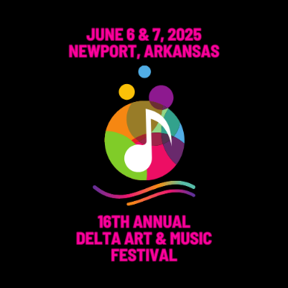

Musicians

Application to Perform

Application information

Full name: |  |  |  |  |  |  | Date:
 |  | Last | First |  | M.I.
Address: |  |  |  |  |  |  | Phone:
 |  | Street address |  |  | Apt/Unit #
 |  |  |  |  |  |  | Email:
 |  | City |  | State | Zip Code

Band Name:

# in Band: |  |  |  |  |  | Contact: |  |  |  | Honorarium: |  | $
Type of Music:

Can you play on Friday, June 6th? |  |  |  | Yes ☐ | No ☐
Can you play on Saturday, June 7th? |  |  |  | Yes ☐ | No ☐
Have you played at the festival before? |  |  |  | Yes ☐ | No ☐ |  | If yes, when?
Are you okay with a plug & play concert? |  |  |  | Yes ☐ | No ☐ |  | If no, explain:
Link to Music

Other Information

